Peak change in DAWN using 2D data
Load your 2D processed data in DAWN in the processing perspective
Scroll through the data until you find an Input slice with your peak of interest.
Step 1:
Add Box Integration
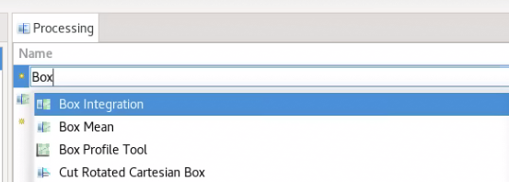
Right click on it and choose save output
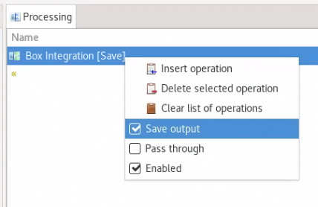
Choose live output button to select your region: 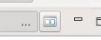
Then in the GUI that opens, select the region in Q you would like to fit:
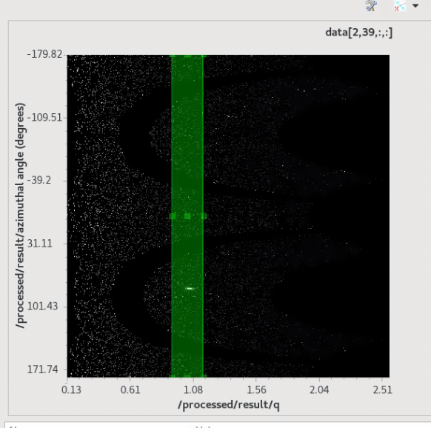
The result should show a peak.
In the output plot below, there should be a peak. Use the drop down ‘XY tools’ (far left icon in image below, then Maths and Fitting>Function Fitting.
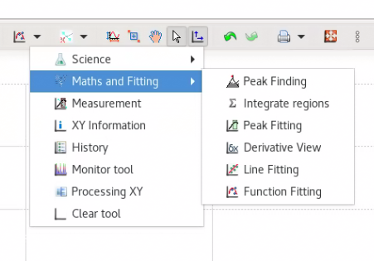
Choose the ‘Find Peaks’ option, then enter the number of peaks (e.g. 1) and the peak type – here we choose Gaussian.
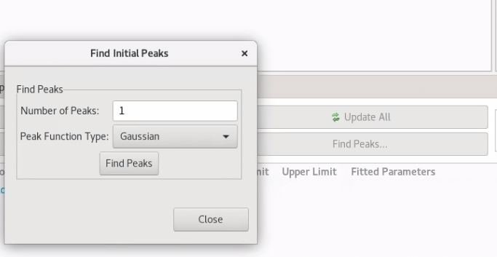
Find the peaks and then save the file using
Add ‘Fit Imported Function’ to the Processing box and choose the file you have just saved.
Press the green play button to run the peak finding for all.

Second option with 1D data
Load 1D data into DataVis
Perform the Peak Fitting using the three little dots>XY Plot>Maths and Fitting>Function Fitting
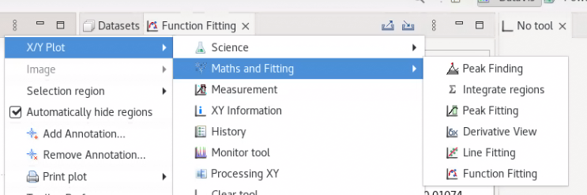
As above, choose ‘Find Peaks’ then 1 Peak, Gaussian in the menu that appears.
Fit the peak and save the .nxs file 
Import the 1D data to the processing perspective (choose processed/result/data) and run the ‘Fit Imported Function’ with your nxs file from the last step as the function file.
Run processing.

