B07-C AP-XPS User Guide v3.0
TPOT_Entry Lock
January 2020

Table of Contents
1. User Induction Checklist 2
2. Sample Manipulator Motion Axes 3
3. Changing Photon Energy 4
4. Initial Alignment via SPECS Prodigy 5
5. XPS Measurements 6
6. NEXAFS Measurements 7
7. Au Foil Standard 8
8. Beamline Transmission Curves 9
9. Introducing Gases (Manual Control) 10
10. Introducing Gases (Butterfly Valve) 11
11. Pumping Out (P > 10-2mbar ) 12
12. Pumping Out (P < 10-2mbar) 12
13. Pumping Out (Manual Control) 12
14. Transferring Samples with Entry Lock 13
15. Eurotherm Operation 15
16. Cooling with Liquid Nitrogen 16
17. Troubleshooting – GDA acquisition problems 17
18. Troubleshooting – PGM Motion Failure 19
19. Troubleshooting – Magnetic Field 20
20. Useful GDA Commands 21
21. Data Visualization/Extraction 23
22. Data analysis 24
23. Beamsize at the sample on B07C 27
24. Au4f spectra under H₂ and N₂ 28
24. Normalization 30
25. Installing the HDF5 package for Igor 31

User Induction Checklist

BEAMLINE INTRO

- Walkthrough
- Beamline staff – introduce, explain roles, how to contact
- LOGIN @ users account in diamond ws-001 computer
- Beamline user guide – red manual
- Food/drink rules – control room only, only hand-held stuff
- Restaurant/kitchens – opening hours
  - Cantine
Weekdays: Breakfast 7.30am – 9.30am.
Evening meal 5.30pm – 8.00pm (last orders at 7.45pm).
Weekends: Breakfast 8.00am – 9.00am.
A packed lunch can be pre-ordered. Orders must be placed by 10 am.
  - Chilton town (~2-3 miles) The Rose & Crown/Main St, Didcot OX11 0RZ
- Remove waste/samples at end of beamtime

SAFETY

- Fire escapes – locations and muster point
- Fire extinguishers – locations, only use if safe/trained
- Gas alarms - procedure
- EHCs – 8787
- Control Room – 8899
- Specific hazards – magnetic fields, high voltages,
- Lone working procedures – notify EHCs
- Motion stops

EXPERIMENTAL

- Vacuum schematic
- EPICS – interlocks, valves, shutter, PGM, mirrors
- GDA – perspectives, running/saving scripts
- Data retrieval/analysis – FTP, DAWN, Igor
- Cryogens – PPE
- Gas bottles – EHCs to connect/replace
- Sample prep – no chemicals, nanomaterials
- Lab 51 – induction & lab form required

- Sign form on door

Sample Manipulator Motion Axes

The standard Diamond axis notation is used – positive is away from the synchrotron.

Xp – along the axis of the analyser (normal to the surface plane at rot = -25)
Zp – along the axis of the beamline
Yp – vertical

Important – always check the step size of the Xp motion (should be maximum 0.01 mm) – never type a number into the control box:

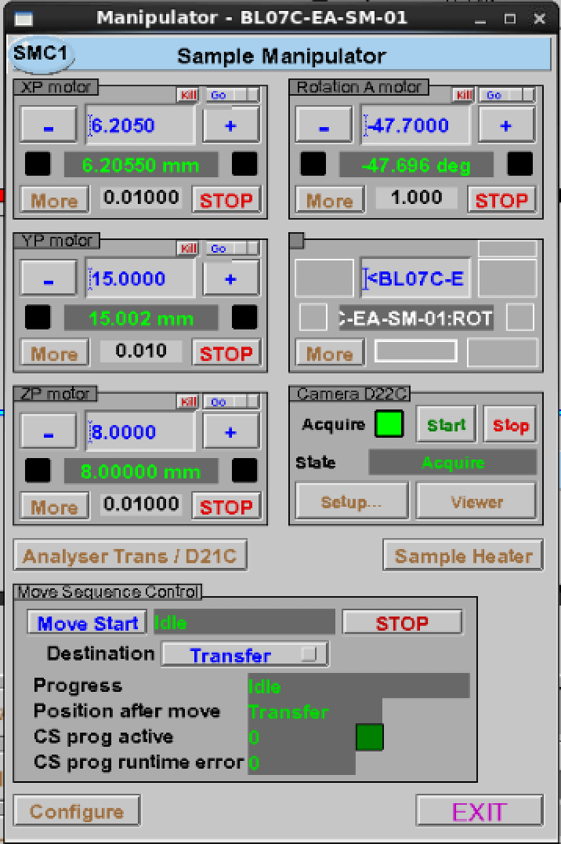
Step size
Do not type in this box

Changing Photon Energy

PGM Energy override
- No override: slow movements – for NEXAFS
- Override : fast movements - XPS
Set the desired energy on the PGMc EPICS screen
Check cff = 2

View D5c_cam2 diagnostic (camera on top of exit slits) to see image of beam centred on the cross (cross at x:540, y:840). It should appear as a “flame” as shown below:

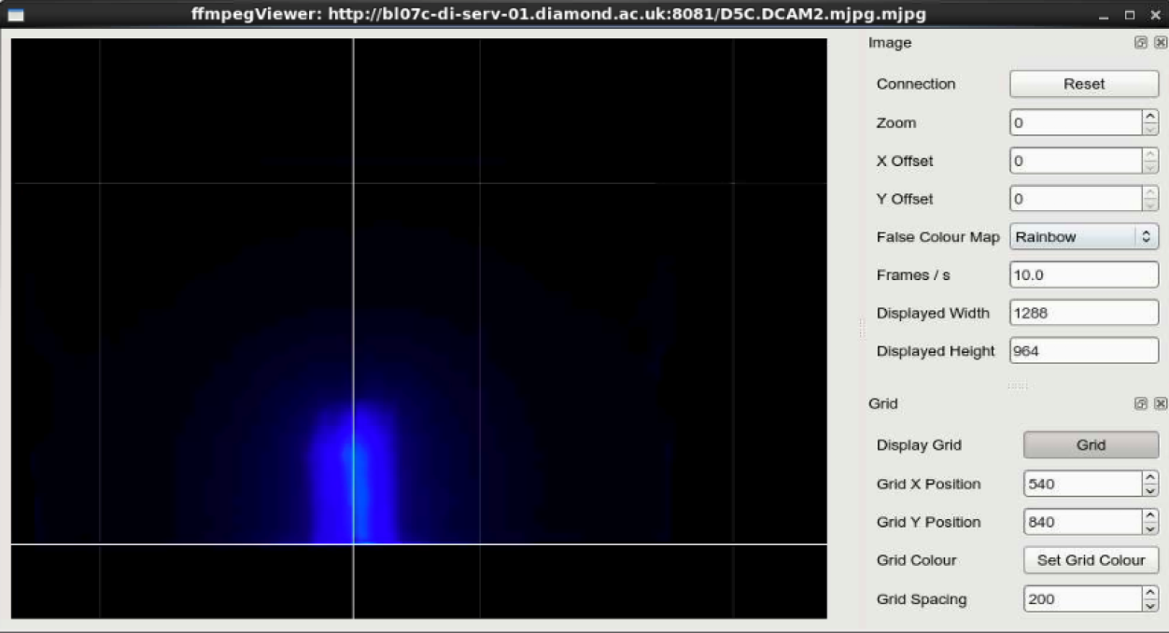

You can try changing the exposure time of D5c_cam2 to get a better image.

Initial Alignment via SPECS Prodigy

Select desired photon energy as described in Section 3

Check sample manipulator is at “Experiment” position

Check that valves 22, 25, 12 and ESHTR (entry shutter) are OPEN.

Reset NAPES vacuum interlocks before opening valve 12

Check that ea_shutter (ESHTR fast shutter in beamline entrance) is OPEN

Open SHTRC experimental shutter

Go to SPECS Prodigy via remote desktop (Diamond Launcher SPECS Analyser PC)

Click Phoibos (magnetic field compensation) @ Device Control

Start fixed energy scan for alignment (check KE, photon energy) @ experiment editor

Move Xp stepwise, (0.01 mm steps) monitoring D98c or D22c camera and maximise counts in analyser

Tweak M4c_pitch and M5c_pitch to maximise counts

Stop the scan running in SpecsProdigy

Important – if you cannot see the laser dot then the sample may be in contact with the analyser cone – STOP approaching immediately.

CAMERAS:

NAP-ES camera D22C set-up exposure…

XPS Measurements

Pre-scan Checks:

- SPECS config file: EPICS_magnetic_field_20171020 (This sets the autocompact to compress both energy and angular channels) @ remote control in SpecsProdigy (unclick “allow” box change click “allow” box again)
- Ensure “Allow remote connections” is ticked in SPECS Prodigy
- Sample is grounded either through FEMTO or via BNC shorting cap. Depending on the sample holder and the experiment the grounding can be either through the drain current connections or through the thermocouple.
- In some cases, charging has been observed when thermocouple is connected.
- PGM energy: OVERRIDE

Example XPS script:

(set up and save name_of_sequence.seq with desired regions etc before sending)

Sequence name
Beamtime
directory

analyser.setSequenceFile('/dls/b07-1/data/2018/si1234-1/xml/name_of_sequence.seq')

scan dummy a 0 0 1 analyser ring_current

PGM energy override

NEXAFS Measurements

Pre-scan Checks:

- PGM energy: NO OVERRIDE
- SPECS config file: EPICS_magnetic_field_20171018 (This sets the autocompact to off for both energy and angular channels) @ remote control in SpecsProdigy (unclick “allow” box change click “allow” box again)
- Thermocouple is disconnected
- Heater is disconnected
- Sample drain current is connected to FEMTO 23
- D21c is in the “Mesh” position (GDA command: pos d21c_positioner ‘New Mesh’)
- Ensure“Allow remote connections” is ticked in SPECS Prodigy

Example TEY script:

End energy
Acquisition time (sec)

scan pgm_energy 500 530 0.5 sample_current 2 femto_21 2 ring_current
Acquisition time (sec)
Energy
step
Start
energy

Example AEY script:

(set up and save name_of_sequence.seq with desired settings for snapshot mode before sending)

Snapshot name
Beamtime
directory

analyser.setSequenceFile('/dls/b07-1/data/2018/si1234-1/xml/name_of_sequence.seq')

scan pgm_energy 280 305 0.05 analyser sample_current 5 femto_21 5 ring_current

PGM energy NO override

Femto_21 I_{o} measurement by mesh (diagnostic 21)
NAP-ES motion ‘mesh’ or ‘out of beam’

Au Foil Standard

Counts during approach

hv:
E_{kin}:
E_{pass}:
T: 1s
Slits:

Au 4f XPS

Beamline Transmission Curves

Introducing Gases (Manual Control)

Open leak valve until pressure starts to rise on HCG-25
Turn OFF emission on HCG-25
Close V24 (isolates turbo)
Continue Opening leak valve slowly until desired pressure on CAP-03/CAP-04

Introducing Gases (Butterfly Valve)

USE ONLY IF INSTRUCTED BY BEAMLINE STAFF

The standard procedure is to go to an intermediate pressure (e.g. 0.5 mbar) before going to P > 1 mbar range

0-0.95 mbar Pressure Range

Open leak valve until pressure starts to rise on HCG-25

Turn OFF emission on HCG-25

Close V48

Open V49 (this will close V24)

Enter desired pressure on V37 (0-0.95 mbar)

Press “Pressure Set” on V37

Open V46

Press “RESET” on V37

Press “OPERATE” on V37

The pressure can then be controlled by entering the desired value and tweaking the leak valve if required. (aim to keep valve at ~15% open condition)

To increase to 1-100 mbar Pressure Range

Enter desired pressure on V37 (1-100 mbar)

Open V48

Press “RESET” on V37

Press “OPERATE” on V37

Pumping Out (P > 10-2mbar )
Close any leak valves

Press ‘pump down sequence select’ button on the end station HMI screen and wait.

Turn HCG-25 back on

Pumping Out (P < 10-2mbar)
Close any leak valves

Check that Turbo 29 is on and Open gate valve 24.

Turn HCG-25 back on

Pumping Out (Manual Control)
Close Leak Valve(s)

Close V49 (could already be closed).
Close V46 (could already be closed)
Open V48 (could already be open)

Enter 0.0 as pressure on V37

Press “Pressure SET” on V37

Press “Pressure RESET” on V37

Open V48

Press “RESET” on V37

Switch HMI key to SERVICE

Go to V37 Service Menu

Open V37

Pump out until CAP-04 ~0.02 mbar

Open V46

Open V24

Restart T29 if required and wait until green

Switch HMI key to NORMAL

Transferring Samples with Entry Lock

Some manipulator transfer positions (@ April 2019):

XP = -0.2346  YP = 11.47  ZP = 5.8004  R = -47.7  Sledge = 1.15 | XP = -0.105  YP = 10.95  ZP = 6.30  R = -47.7  Sledge = 1.15

Transfer Samples from Analysis Chamber to the Entry Lock
Analysis Chamber and Entry Lock both should be in high vacuum.
- Close SHTRC
- Close GV 12
- Close ESHTR
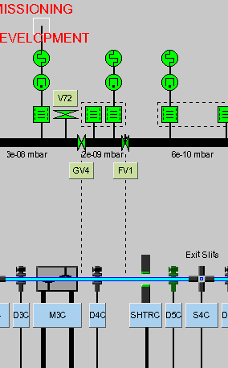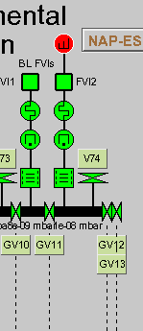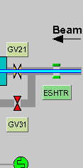

- Make sure all leak valves are closed and the analysis chamber is in high vacuum. See high vacuum gauge in HCG 25. Pressure should be below 10-6 mbar.
- Retract sample few steps, by clicking – in Xp of sample manipulator. [NAP-ES>Motion]
- Then select SAFE and move.
- Select Transfer and move start
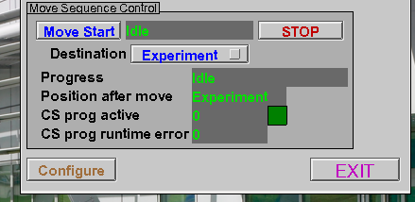

- Open V81 [Valve between Analysis chamber and entry lock] from Entry Lock Control panel screen.
- Close air supply to sample station. Turn to equatorial/horizontal position
- Move the arm in to pick up the sample.
Retract sample back to the entry lock and close V81.

Vent the Entry Lock

Go to the entry lock panel screen
- V81 should be close
- Close V83
- Close V84
- Open Small flow of argon in the venting nitrogen bottle
- Open V82
You should see 1000 mbar in the pressure gauge of entry lock.

Now open the entry lock to change or put your sample holder.

Pump down the Entry Lock

Go to the entry lock panel screen
- Close the entry lock door.
- Close V82 (the vent valve)
- Close venting nitrogen flow from the cylinder regulator.
- Open V85, Pump down to 1 x 10-2 mbar. Look at the gauge.
- Then, close V85.
- Open V84, Start Turbo pump, Open the V83.
- You should see a good vacuum, less than 1 x 10-5 mbar, look at the gauge.

Transfer Sample from Entry Lock to Analysis

Entry Lock and analysis chamber should be in high vacuum.

Analysis chamber sample station should be in transfer position. [NAP-ES > Motion]. Compressed air to sample manipulator off. The blue knob of compressed air in horizontal.

- The transfer arm should be tilted, aligned for the analyzer. See the marks on the entry lock knob to align it for analysis chamber.
- Open V81 (from entry lock panel screen)
- Rotate the furthest knob in entry lock to move arm to enter sample in to mounting station.
- When sample is positioned inside the manipulator groove, Switch on air supply. Blue knob in vertical.
- Now release the arm and retract it completely to the entry lock.
- Close V81.

Eurotherm Operation

RETRACT SAMPLE BEFORE HEATING!

The eurotherm can be used either manually, through its EPICS control window, or via GDA.

Pre-heating Checks:

- Ensure that the heater cable is connected at the manipulator
- Ensure that the thermocouple (green cable) is connected at the manipulator and a sensible temperature is being read by the Eurotherm
- Ensure the power supply (above Eurotherm) is switched ON
- Ensure the sample has been retracted away from the analyser cone
- Compressed air to be flowed through the manipulator

Heater EPICS Operation (located at NAPES Motion Sample heater):

- Type desired heating rate and temperature set point
- When at stable temperature, re-approach analyser cone with fixed energy scan
- For more rapid cooling after heating experiment, ask for compressed air to be flowed through the manipulator – see beamline staff

GDA script that records XPS at 10° increments from 100-400 °C:

analyser.setSequenceFile('/dls/b07-1/data/2017/siXXXX-1/xml/name_of_sequence.seq')
scan sample_temperature 100 400 10 analyser

Other Commands:

To know the current ramp → sample_temperature.getRampRate()
To select/change a 5 °C/min ramp → sample_temperature.setRampRate(5)
To set the new set point → pos sample_temperature XXX
To stop the ramp before raise the final temperature → sample_temperature.stop()
To set the accuracy level → sample_temperature.setAccuracy(1.0)
To get the current accuracy level → sample_temperature.getAccuracy()

Cooling with Liquid Nitrogen

If desired, temperatures down to 150 K can be achieved by flowing liquid nitrogen through the manipulator as follows.

Check that the setup is connected as shown in the cartoon below (ensure that there is sufficient insulation around all pipes):

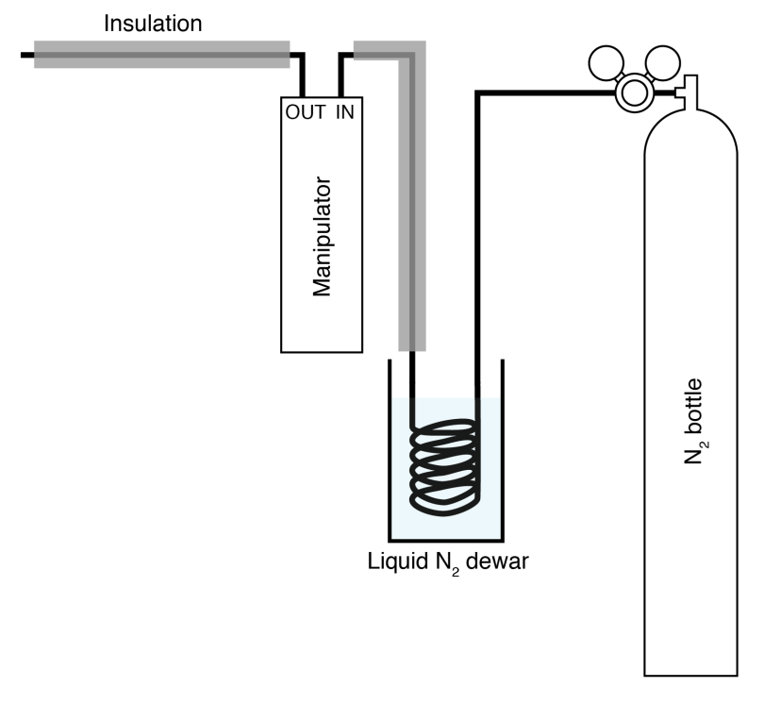

Cooling Procedure:

Flow N₂ through for ~10 mins to purge any oxygen from the lines

Fill dewar with liquid N₂ (wearing appropriate PPE)

Adjust N₂ flow as required to keep desired temperature

Warming up Procedure:

Remove dewar

Continue blowing N₂ through until all liquid is consumed in the heat exchanger

Close off N₂ flow and disconnect (pipes will be very cold!!!)

Troubleshooting – GDA acquisition problems

If the scan fails to run – first check that the analyser EPICS interface is still connected: Go to the synoptic and select NAP-ES:SPECS Analyser and check that the CCD is connected (if not, just click reconnect)

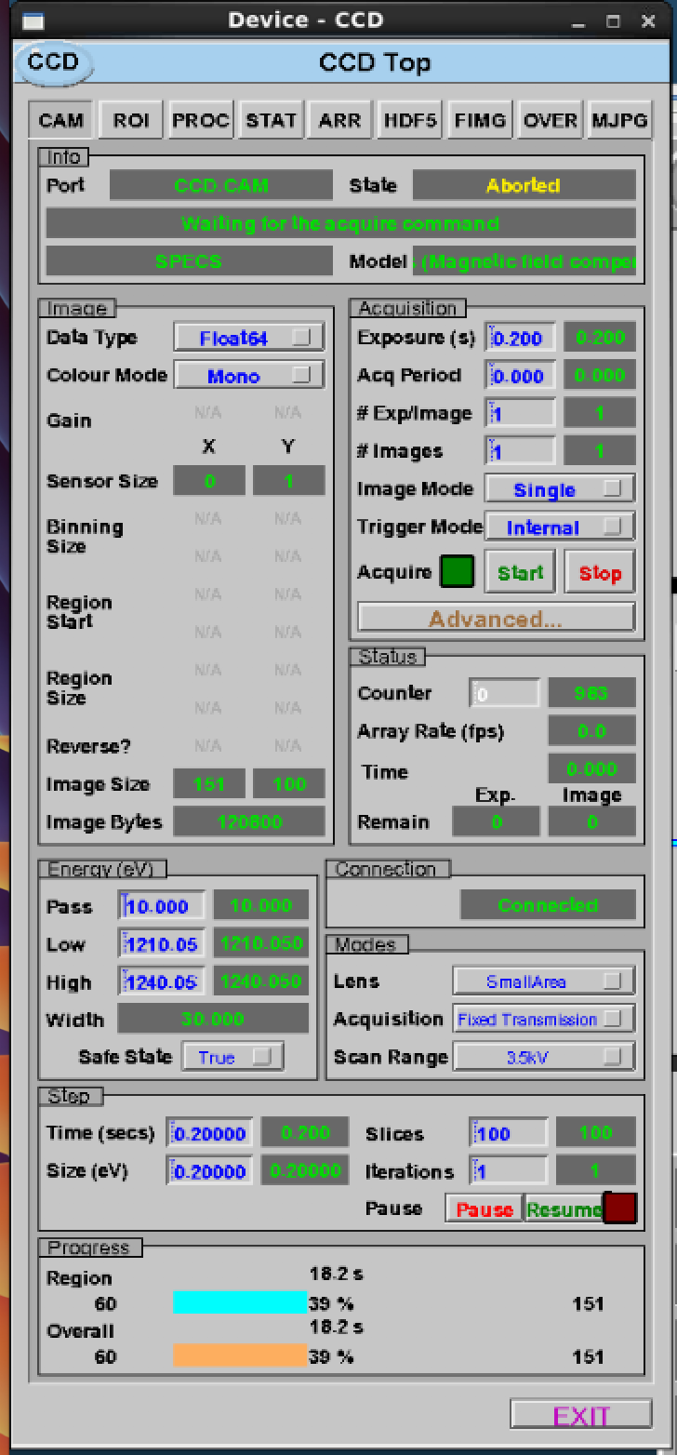
Connection status

The connection between GDA and the analyser occasionally drops out, which results in slow/faulty updating of the spectra within the GDA window. To recover, in the first instance try the following:

Dump current plot data (save to nexus file)
Close the GDA client
Restart GDA server (Diamond Launcher Start B07-1 GDA Servers)
Wait until this process finishes (generally a couple of minutes)
Restart GDA client (Diamond Launcher Start B07-1 GDA Client)

In case this doesn’t resolve the problem, a reset of the IOC may be required, as detailed below:

Close the GDA client
Go to “Hardware Status” on synoptic screen (lower left)
Click Start/Stop tab for NAPES (Analyser) BL07C_EA_IOC_02
Restart this IOC
Restart GDA server (Diamond Launcher Start B07-1 GDA Servers)
Restart GDA client (Diamond Launcher Start B07-1 GDA Client)
Reconnect analyser in EPICS window

Troubleshooting – PGM Motion Failure

An amplifier loss on the Geobrick that controls the PGM can be recovered as follows:

- By pressing STOP on the energy window of the PGM screen and inputting the desired value again.

- Hardware status Geobrick PGMc Terminal Connect type: ena plc6 Send Disconnect

Troubleshooting – Magnetic Field

- Disconnect the device in Specs prodigy
- Switch off the three power supplies of the coils
- Unplug and re-plug the Armin plug into the socket. It is in the rear part of the analysis rack 3, bottom right, and labelled.
- Switch on the three power supplies
- Connect the device in Specs prodigy
- Check if the enable LED is on in the three power supplies

Useful GDA Commands

GDA Command  (italics = stuff you can change) | What it does
analyser.getWorkFunction() | Gets current value of workfunction
analyser.setWorkFunction(5) | Sets value of workfunction
femto_name.setSettleTime(500) | Sets settle time of femto_name
femto_name.setAutoGain(True/False) | Sets autogain on/off for femto_name
femto_name.isAutoGain() | Gives autogain setting for femto_name
pos expt_shutter 'Close' | Closes experimental shutter (replace Close-Open)
pos pgm_energy 743.3 | Sets photon energy to 743.3 eV

Femto Names
sample_current | Sample drain current (Femto 23)
femto_22 | BLE aperture (Femto 22)
femto_21 | Diagnostic 21 (Femto 21)
femto_xx | Gas cell
femto_xx | Gas cell photodiode

Acquiring XPS spectrum via script

analyser.setSequenceFile('/dls/b07-1/data/2018/siXXXX-1/xml/name_of_sequence.seq')
scan dummy a 0 0 1 analyser

Acquiring NEXAFS spectrum via script

pos ea_shutter ‘Close’

pos pgm_energy 280
pos d21c_positioner ‘Mesh’

pos ea_shutter ‘Open

analyser.setSequenceFile('/dls/b07-1/data/2018/siXXXX-1/xml/name_of_sequence.seq')
scan pgm_energy 280 305 0.05 analyser sample_current 5 femto_21 5

pos ea_shutter ‘Close’

pos d21c_positioner ‘Out of Beam’

The above scans the photon energy from 280 eV to 305 eV, in 0.05 eV steps, acquiring AES NEXAFS via the analyser (assuming snapshot mode), TEY from the drain current, and an I0 from the mesh on d21c.
Changing Grating via GDA --> all need to be checked

#400l/mm grating, mirror: Pt stripe
pos pgm_grating '400 lines/mm'
pos pgm_mirror 'Pt Stripe'

#400l/mm grating, mirror: Rh stripe
pos pgm_grating '400 lines/mm'
pos pgm_mirror 'Rh Stripe'

# 600l/mm grating: Rh stripe, mirror: Rh stripe
pos pgm_grating '600 lines/mm'
pos pgm_grating_x -91.7
pos pgm_grating_x -91.9
pos pgm_mirror 'Rh Stripe'

# 600l/mm grating: Rh stripe, mirror: Pt stripe
pos pgm_grating '600 lines/mm'
pos pgm_grating_x -91.7
pos pgm_grating_x -91.9
pos pgm_mirror 'Pt Stripe'

# 600l/mm grating: Pt stripe, mirror: Pt stripe

pos pgm_grating '600 lines/mm'
pos pgm_grating_x -107.1
pos pgm_grating_x -106.9
pos pgm_mirror 'Pt Stripe'

# 600l/mm grating: Pt stripe, mirror: Rh stripe
pos pgm_grating '600 lines/mm'
pos pgm_grating_x -107.1
pos pgm_grating_x -106.9
pos pgm_mirror 'Rh Stripe'

Data Visualization/Extraction

GDA: Script perspective
Specs perspective
DataVis

DAWN: (module load dawn\2.5 dawn @ October 2017)
Trace or DataVis perspective to visualize and compare:
File new project Data Data project (linked…) select the external folder

Data extraction:

Windows PC explorer: \\data.diamond.ac.uk\b07-1\data\2019

FTP: Load your data from your explorer at: \\diamftpserv01\ftpanon\B07
Take the data from: ftp://ftpanon.diamond.ac.uk/B07/

Dawn: Convert .nxs to XY
Processing Perspective
Select a file dataset: spectrum
line [1d]
select KE, BE..
Processing window export to text file
Run from data slice view window

To convert to .txt files:
Within the processing folder of your own experiment folder (typically dls/b07-1/data/2019/sixxxxx/) create a new folder named convert in processing and copy the data files to that folder.
Then from a terminal input the command:
/dls_sw/b07-1/scripts/b07_convert_nxs_to_txt_new.py /dls/b07-1/data/2019/sixxxx/processing/convert
- Data extracted: kinetic_energy vs intensity
/dls_sw/b07-1/scripts/b07_convert_nxs_to_txt_new2.py /dls/b07-1/data/2019/sixxxx/processing/convert
- Data extracted: binding_energy vs intensity
This will makes .nxs files in the ‘convert’ folder to .txt files

Data analysis

Users can analyse their data in the beamline hutch windows computer with Igor pro software.
Copy/access your data.
- Make a local folder to copy your data.
- If you are logged in with your credential (diamond login id and password),
Then type \\data.diamond.ac.uk in the address bar to access your data from
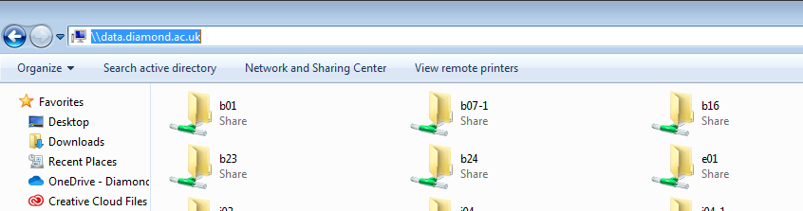
B07-1>data>2019>your data directory (for example si2218184-1)

- If you are logged in as b071user then you have to access your data from the same directory through ftp via Filezilla ftp client software
Your data folder path: dls/b07-1/data/2019/SIxxxx
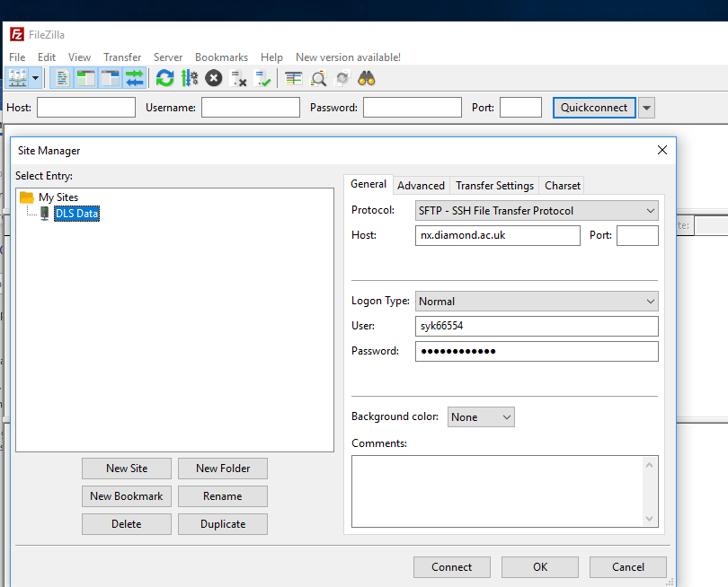
Put your diamond username
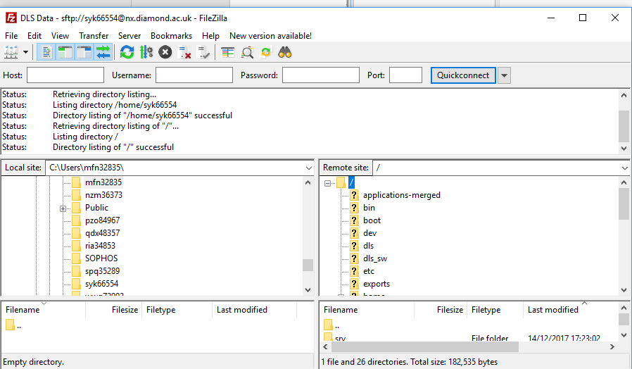

Igor procedure files
We have two procedure macros for igor, which enables us to easily convert nexus files into igor waves and analyse xps data.
- In Igor pro macros HDF Files allow you to convert nexus data files to igor binary waves

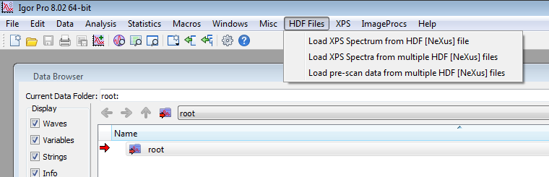
- XPS macro allows you to perform some analysis like normalization, background subtraction, fermi energy correction etc.

- If you are logged in as b071user
The macros are already loaded.

- If you are logged in as yourself (your user name)
First check if you have hdf browser installed in igor.
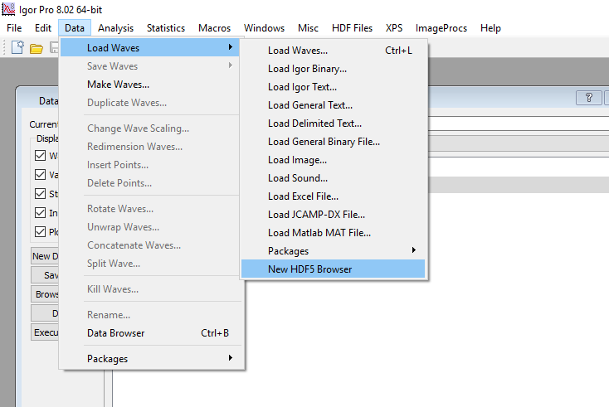
If yes, then load the macros directly from.\\diamftpserv01\ftpanon
B07-->Igor macros

If you do not see hdf browser installed. First install the hdf browser and then load macros.

Beamsize at the sample on B07C

Measurement Procedure:

PGM: 600 l/mm; Pt mirror
Photon energy: 1200 eV

Sample: thin rectangular mica sheet (<<0.1 mm x 11 mm x 7 mm) on bare sample holder; edges aligned with yp/zp directions of sample manipulator. The sample holder is at normal incidence.

y gap size / mm | vertical beam size 12% - 88% / mm
0.200 | 0.103
0.150 | 0.090
0.100 | 0.075
0.075 | 0.070
0.050 | 0.066
0.025 | 0.062 / 0.065

z gap size / mm | vertical beam size 12% - 88% / mm
0.173 | 0.090
0.185 | 0.090

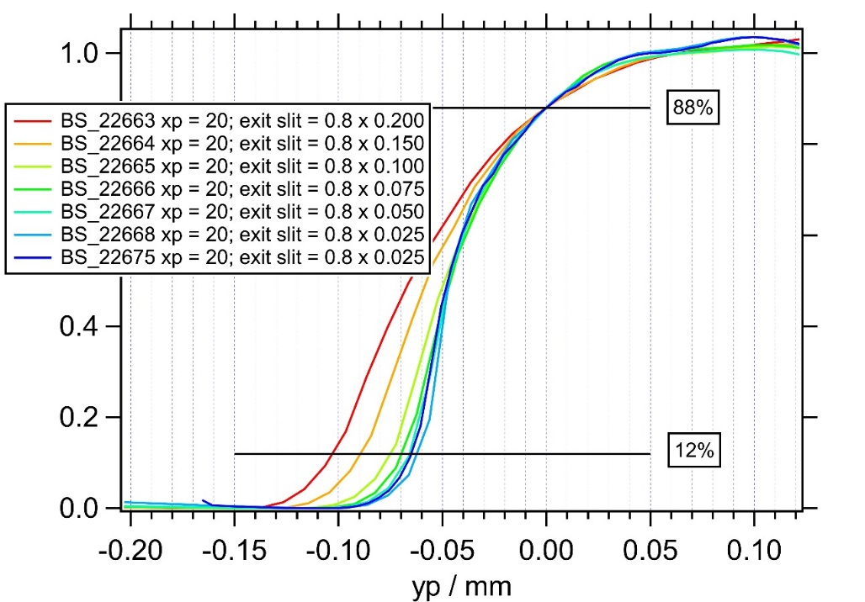
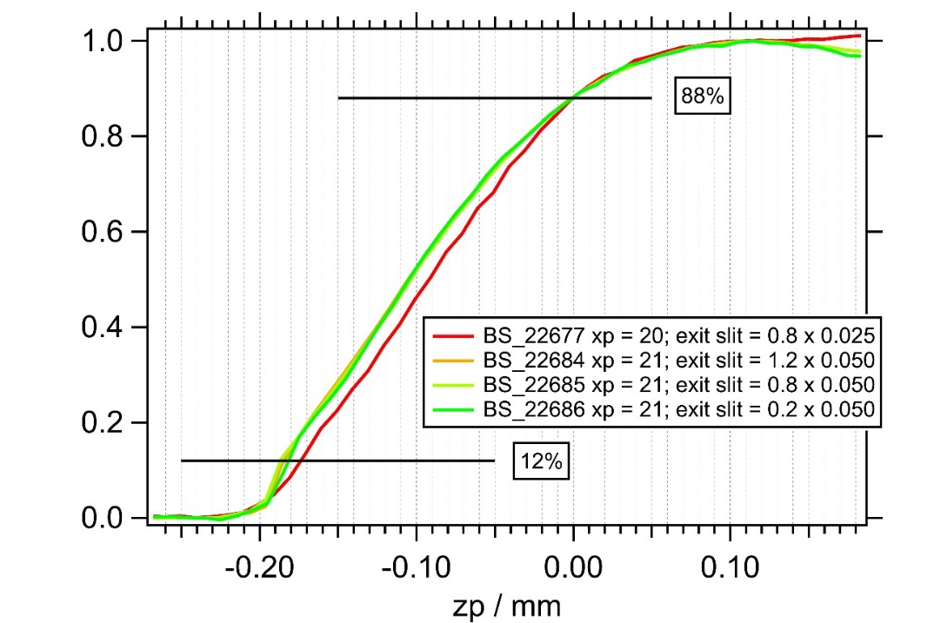

Au4f spectra under H₂ and N₂
hυ = 500 eV S4c = 0.8 x 0.05
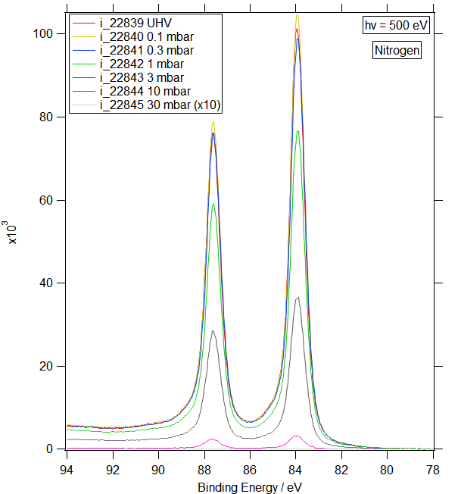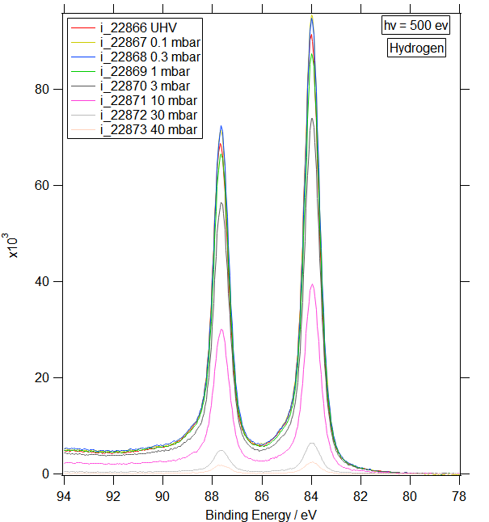

hυ = 500 eV S4c = 0.8 x 0.05
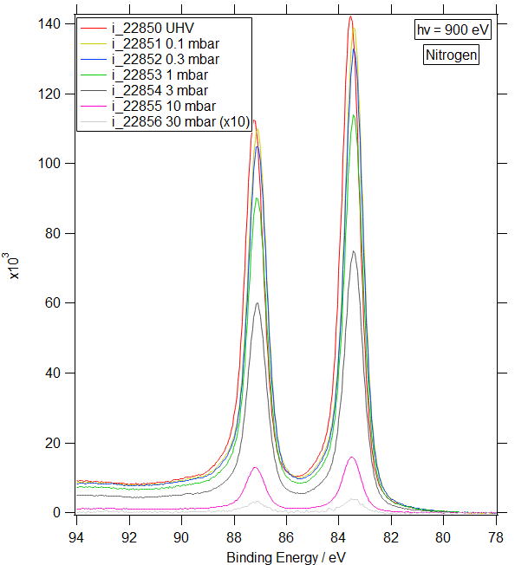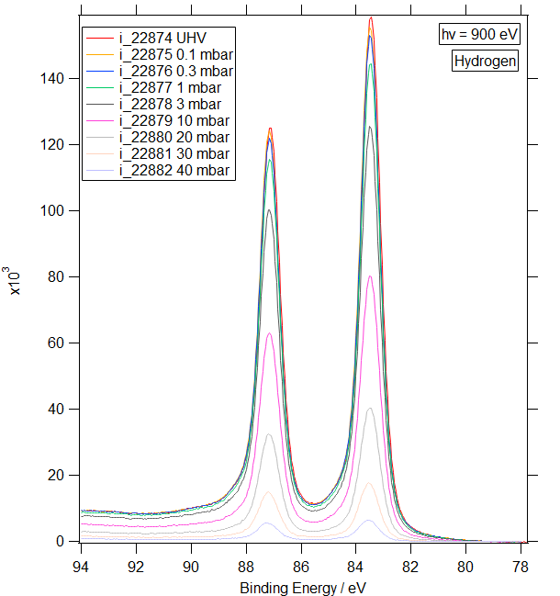

hυ = 500 eV S4c = 0.8 x 0.025
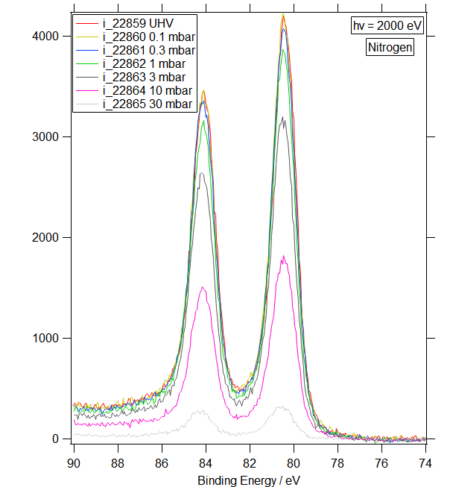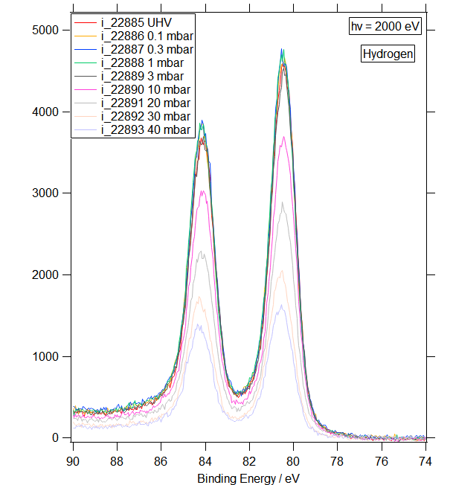

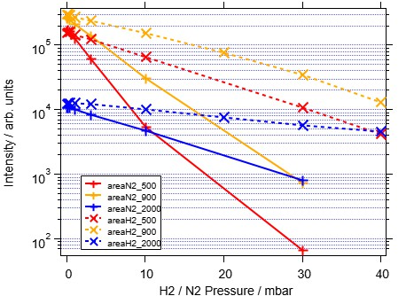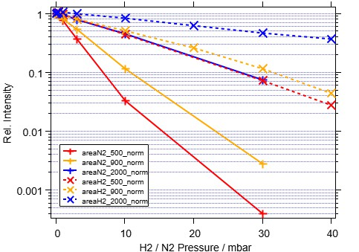

Normalization

TOP-UP normalization:
- ring_current
- S2c as detector GDA Command (s2c_ytop_current)

Installing the HDF5 package for Igor

Installing HDF5 requires activating two files – the HDF5 XOP file and the “HDF5 Browser” procedure file – by placing aliases (Mac OS X) or shortcuts (Windows) for them in special folders.
A. From the Help menu, choose “show Igor Pro User Files”. This displays the Igor Pro User Files folder on the desktop. These instructions assume that you are using the 64-bit version of Igor.
From the Help menu, choose “Show Igor Pro Folder”. This displays the Igor Pro Folder on the desktop.
Make an alias (Mac OS x) or shortcut (Windows) for the following file: Igor Pro Folder\More Extensions (64-bit)\File Loaders\HDF5-64.xop
Move the alias or shortcut into “Igor Pro User Files\Igor Extensions (64-bit)”. This activates the HDF5 XOP, which adds operations to Igor for interaction with HDF5 files.
The HDF5-64.xop file contains within it the necessary HDF5 libraries so you do not need to install libraries from the HDF Group.
B. Make an alias (Mac OS X) or shortcut (Windows) for the following file:
Igor Pro Folder\WaceMetrics Procedure\File Input Output\HDF5 Browser.ipf
Move the alias or shortcut into the “Igor Pro User Files\Igor Procedures” folder. This activates the procedure file that implements an HDF5 browser and adds a “New HDF5 Browser” menu item in the Data Load Waves menu.
C. Restart Igor Pro and then read the HDF5 Guided Tour section below.

To uninstall the HDF5 package, delete the aliases or shortcuts created above and restart Igor.
For background information on special folders such as the Igor Extensions and Igor Procedures folders, see Special Folders.

