Looking at XRD data in DAWN
You will need either xrd1d or xrd2d data for this tutorial.
If your XRD data is unprocessed, use the websubmitter instructions to process them first, as the raw files write as a line, rather than a map.
Open dawn using
module load dawn
dawn

Looking at XRD1D data
Open the _xrd1d file in DAWN. Click on the tick box next to your data to display it.
The DataVis perspective will show you the 2D detector data from your map when you choose ‘/entry/excalibur_addetector/data’ on the right hand side. You can scroll through using the x and y scroll bars that appear when you click on the ‘Start:Stop:Step’ area, below the datasets box.
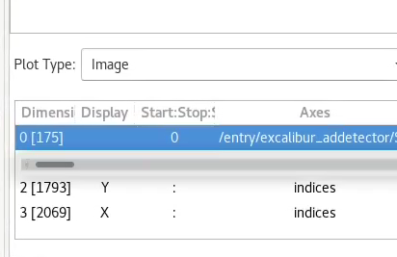

To see the 1D information, change the dataset to ‘/processed/result/data’ and the Plot Type from Image to Hyper3D. This will show your map area on the right, and the 1D data on the left. The blue box on the left area controls the graph shown on the right (it is the sum of the 1D patterns from all the pixels in the left blue box).
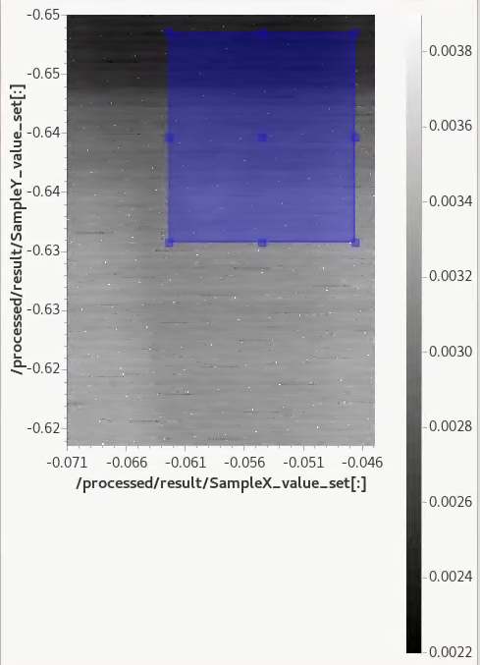
You can also change the width of the blue area in the right hand plot, to select a peak. This will change the right hand map view to show the intensity of this peak at each pixel.
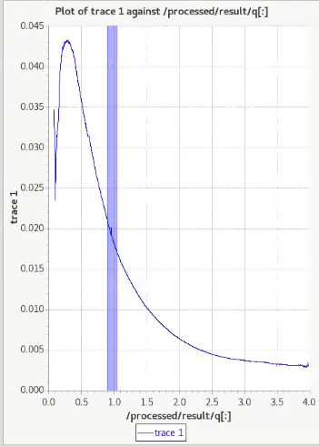
A high background can sometimes occur in the 1D image. You can try different options for background correction using the websubmitter, but this is currently a trial and error process.

Looking at 2D data
Data that has been processed using the xrd2d option will give you a graph of azimuthal angle vs q for each pixel instead of the detector image. In this way, you will see what would be a ring in the detector in a line, with associated q value. You can scroll through them per pixel as with the 1D information. The hyper3D will not work with two 2D patterns (the map and the 2D detector data).

