Reprocessing using the I14 web submitter

1.1 Starting the web submitter
To start the web submitter, open a new terminal on a Linux workstation (via a remote connection to nomachine if offsite) and type:
module load i14webapp/

setup_web_app_i14.sh
Then view the web submitter in a browser window:
http://localhost:8082/

Once you've started the service and connected via a browser you will get a basic interface.
From here you can:
- Submitter jobs to the cluster - using the 'Launch I14 Process submitter' option
- Browse the .html, .png or .gif outputs from the processing (note that the file browser can take a few seconds to read a folder contents and display)
- Launch JupyterHub, ISpyB, I14 web pages, etc.
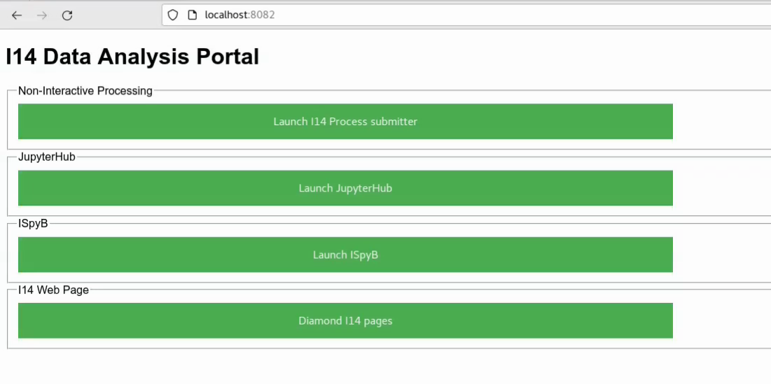
For XANES choose ‘Launch I14 Process submitter’
1.2. Submitting Jobs to the cluster
After selecting the 'Launch I14 Process submitter' button, the web submitter interface will be loaded, which is hopefully self explanatory:
- Select the visit directory by typing the experiment folder which will filter the entries in the drop-down menu.
- Select a folder name to store results in (if the folder does not exists, it will be generated)
- Select the type of workflow to run (Single scan, Multiple scans or Batch processing). Select the processing workflow from the dropdown and the scan number. For XANES choose ‘multiple scans’.
- Select the config file for the workflow. When you select a config it is copied to a tmp folder in /dls/tmp/i14/date_time - where date_time is the time you started the web_app. For XRD workflows, once the config files has been selected you can overwrite the calibration, detector mask and flat field paths supplied in the config file. XANES and DPC do not need a config file.
Final notes:
The results will be saved at the output folder selected in the Step 2. Please, navigate through the data in the usual way (i.e., remote connection to I14 Linux via NoMachine).
The workflows currently do not submit results to iSpyB but most workflows create a html output or png/tiff or gifs depending on the workflow.
These can be examined via the web file browser - clicking on a .html, .png or .gif will display it in the browser.

