XRD reprocessing using the I14 web submitter

1.1 Starting the web submitter
To start the web submitter, open a new terminal on a Linux workstation and type:
module load i14webapp

setup_web_app_i14.sh
Then view the web submitter in a browser window:
http://localhost:8082/

Once you've started the service and connected via a browser you will get a basic interface.
From here you can:
- Submitter jobs to the cluster - using the 'Launch I14 Process submitter' option
- Browse the .html, .png or .gif outputs from the processing (note that the file browser can take a few seconds to read a folder contents and display)
- Launch JupyterHub, ISpyB, I14 web pages, etc.
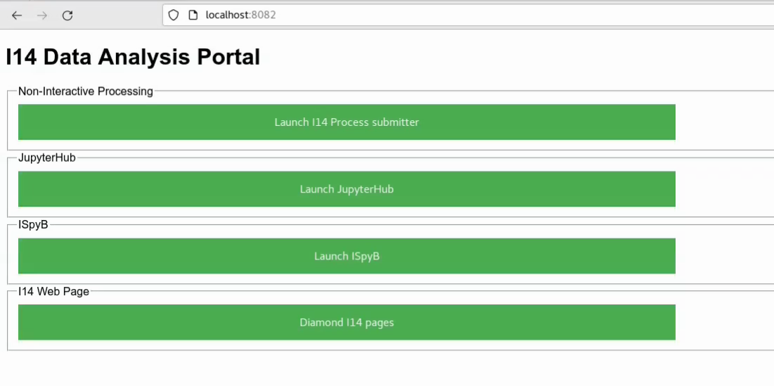
For XRD choose ‘Launch I14 Process submitter’
1.2. Submitting Jobs to the cluster
After selecting the 'Launch I14 Process submitter' button, the web submitter interface will be loaded, which is hopefully self explanatory:
- Select the visit directory by typing the experiment folder which will filter the entries in the drop-down menu.
- Select a folder name to store results in (if the folder does not exists, it will be generated)
- Select the type of workflow to run (Single scan, Multiple scans or Batch processing). Select the processing workflow from the dropdown and the scan number. For batch processing (i.e. more than 1 XRD scan at a time), use XRD_1D_BATCH or XRD_2D_BATCH. For single scans XRD_1D or XRD_2D.
- Select the config file for the workflow. When you select a config it is copied to a tmp folder in /dls/tmp/i14/date_time - where date_time is the time you started the web_app. For XRD workflows, once the config files has been selected you can overwrite the calibration, detector mask and flat field paths supplied in the config file.
Changing the XRD config file to add in background correction:
Within your pyfai_live.yaml file (usually in your processing folder>xrd_calibration), you can change the background correction:
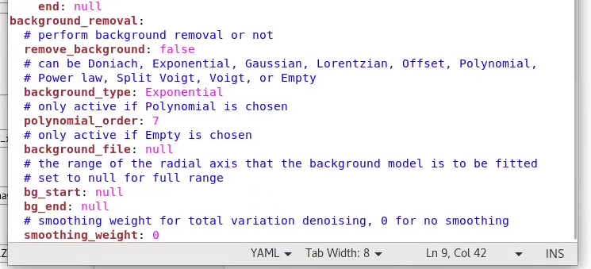by changing ‘Remove_background’ to true, and then choosing the background type.
If you have a background file, you can write in the file path (this is untested).
You can also change the smoothing and region the background is applied to as you wish.
In this file you can also change the mask to point to another mask file if there is something else you’d like to mask out.
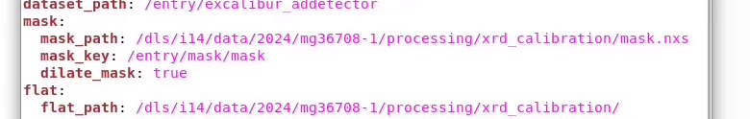
You can check the mask that’s being used by opening it in DAWN as you would another file.
To adjust the mask or make a new one you can use the ‘Masking (Fast)’ option in DAWN accessed via the toolbar of your image (red circled icon):
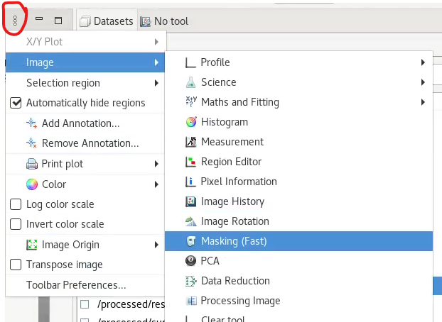
Using a summed Excalibur image (via SUM FRAMES) can be the easiest way to see the things you want to mask.
Use the drop down to select a shape, then ‘draw’ to draw the shape onto your image. Click apply to apply it, which will make it green. Once complete, you can save it using the save button in the Masking tab (shown below):
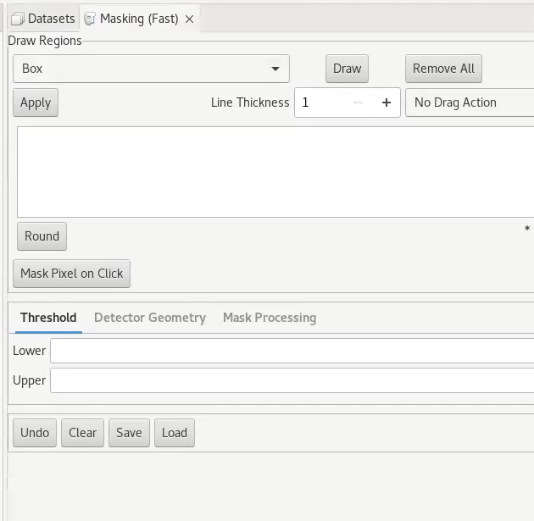

Final notes:
The results will be saved at the output folder selected in the Step 2. Please, navigate through the data in the usual way (i.e., remote connexion to I14 Linux via NoMachine).
The workflows currently do not submit results to iSpyB but most workflows create a html output or png/tiff or gifs depending on the workflow.
These can be examined via the web file browser - clicking on a .html, .png or .gif will display it in the browser.

