
ITSF 2025 (22-26 September) Provisional Schedule

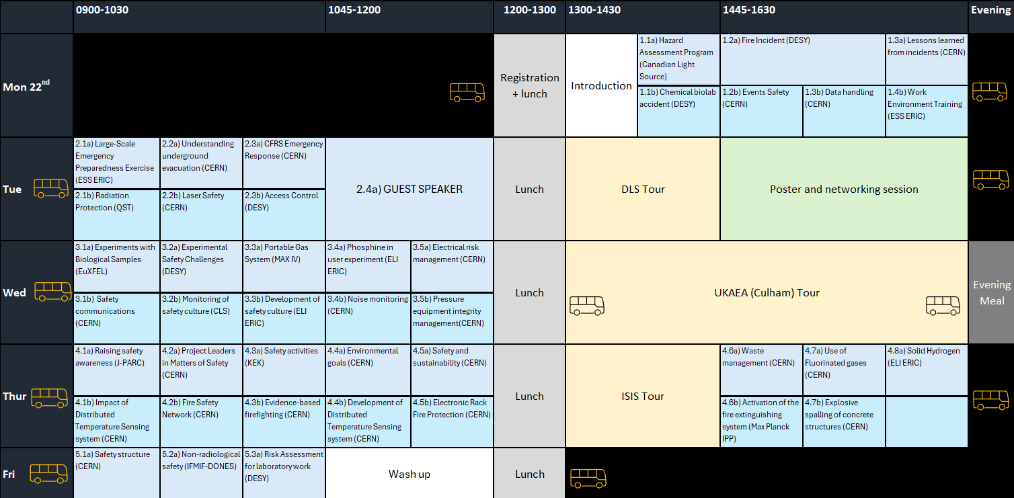


Verbal Presentations

Visitor Centre
Monday | 14:00 | 1.1a | Meghan Allen: Navigating the Safety Maze: Lessons from the Implementation of a Hazard Assessment and Control Program
 | 14:45 | 1.2a | Sven Mohr & Fabian Saretzki: Fire incident at DESY II facility
 | 15:45 | 1.3a | Myriam Ayass: Lessons learned from incidents, injuries or near misses
Tuesday | 09:00 | 2.1a | Therese Geber Bergstrand: Exercise Matilda: Lessons Learned from a Large-Scale Emergency Preparedness Exercise at the European Spallation Source
 | 09:30 | 2.2a | Lorenzo Contini: EvacAnalyst: Using CCTV cameras to understand underground evacuation and built-up statistics. A CERN case study.
 | 10:00 | 2.3a | Marc Nas: Transforming CFRS Emergency Response: Robots, Data, and CrossBorder Collaboration
 | 10:45 | 2.4a | Guest speaker
Wednesday | 09:00 | 3.1a | Kristina Lorenzen: Safety and Regulatory Challenges for Experiments with Biological Samples at EuXFEL
 | 09:30 | 3.2a | Anca-Simona Ciobanu: Experimental Safety Challenges at the Photon Science Division
 | 10:00 | 3.3a | Marcin Bielawski: Safer Experiments at MAX IV: Implementing a Portable Gas Safety System
 | 10:45 | 3.4a | Petra Dvorakova Ruskayova: Highly dangerous phosphine in user experiment
 | 11:15 | 3.5a | Anne Laure Perrot & Maria Papamichali: Gearing Up for Improved Electrical Risk Management in the CERN Accelerators Complex
Thursday | 09:00 | 4.1a | Kotaro Bessho: J-PARC Safety Day to Raise Safety Awareness and Share Safety-related Approaches
 | 09:30 | 4.2a | Simon Marsh: Supporting CERN’s Project Leaders in Matters of Safety
 | 10:00 | 4.3a | Ichiro Adachi: Safety Activities at Institute of Particle and Nuclear Studies
 | 10:45 | 4.4a | Sonja Kleiner: CERN’s environmental goals for horizon 2030
 | 11:15 | 4.5a | Klaus Barth: Integrating Safety and Sustainability in the ALICE 3 Detector Upgrade at CERN
 | 14:45 | 4.6a | Sabrina Schadegg: CERN's Waste Management: Strategies and Roadmap to 2030
 | 15:15 | 4.7a | Michaela Alessi: The challenges of using Fluorinated Gases (F-Gases) in Research Infrastructures
 | 15:45 | 4.8a | Libuse Arnostova: Solid Hydrogen Experiments: Lessons Learned and Innovations Implemented
Friday | 09:00 | 5.1a | Andreas Herty: Safety Structure at CERN – Common Questions in Preparation of Long Shutdowns
 | 09:30 | 5.2a | Danyl Perez Sanchez: Implementation of Codes and Standards for Non-Radiological Safety in the IFMIFDONES Facility
 | 10:00 | 5.3a | Sabine Lessmann-Bassen: Risk assessment for Laboratory Work in DESY Photon Science User Facilities

Pickavance Lecture Theatre
Monday | 14:00 | 1.1b | Franziska Papenfuss: Chemical accident in a biolab – How ventilation failure, multiple employers and occupational safety interfere
 | 14:45 | 1.2b | Laure Tranchand & Roberto Perruzza: CERN70th Anniversary Events – Safety management and organisation
 | 15:15 | 1.3b | Andreas Herty: EIS documentation: unchanged concept – improved data handling
 | 15:45 | 1.4b | Helen Boyer: Navigating Work Environment Training
Tuesday | 09:00 | 2.1b | Masayuki Hagiwara: Radiation Protection at a New 3 GeV Synchrotron Radiation Facility: NanoTerasu
 | 09:30 | 2.2b | Jordan Minier: Laser Safety Training at CERN: Engaging busy minds to enable safer laser operations
 | 10:00 | 2.3b | Sabine Brinker: Access control at DESY - Development in Recent Years / Preparation for PETRA IV
Wednesday | 09:00 | 3.1b | Anna Cook: Navigating complexity: Safety communications at CERN
 | 09:30 | 3.2b | Grant Cubbon - Monitoring Safety Culture at the Canadian Light Source
 | 10:00 | 3.3b | Veronika Olsovcova - Development of Health and Safety culture and behaviour
 | 10:45 | 3.4b | Jordan Minier: Towards a robust noise monitoring network at CERN: results from a pilot study
 | 11:15 | 3.5b | David Tshilumba: Pressure Equipment Integrity Management at CERN
Thursday | 09:00 | 4.1b | Lorenzo Contini: Impact of Distributed Temperature Sensing system (DTS) on occupants’ safety and firefighters’ intervention in accelerator tunnels
 | 09:30 | 4.2b | Saverio La Mendola: Fire Safety Network as Spark of ITSF: 10-Year Retrospective and Way Forward
 | 10:00 | 4.3b | Matthias Van de Veire - From physics to firefighting Evidence-Based Firefighting at CERN
 | 10:45 | 4.4b | Lorenzo Contini: Development of a radiation-resistant Distributed Temperature Sensing (DTS) system for fire and cryogenic leak detection in accelerator tunnels
 | 11:15 | 4.5b | Cedric Gerlach: Electronic Rack Fire Protection Study for CERN´s CMS Experiment
 | 14:45 | 4.6b | Sven Degenkolbe: Lessons learned from activation of the fire extinguishing system at Wendelstein 7-X
 | 15:15 | 4.7b | Marco Andreini: Probabilistic model for explosive spalling of concrete structures subject to fire


Poster Presentations
Tuesday (PM)
Kotaro Bessho: Monitoring system for target soundness by radiation detectors at J-PARC Hadron Experimental Facility
Tim Birkin: Applied safety at ESS - establishing relations and trust
Akihiro Takeuchi: Comparison of Radiation Safety Systems between NanoTerasu and Diamond Light Source
Roberto Perruzza: Integrated Fire Safety Strategy for CMS - A Multi-Tiered Fire Protection Approach
Simon Marsh: From Classification to Delivery - Ensuring Safe Hazardous Material Transport at CERN


Guidance for Conference Delegates Delivering Oral Seminars

Timing
- 20 minutes speaking
- 10 minutes questions / discussion
- Please practice to ensure that you keep withing the 20 minutes. (Bear in mind, some of your audience may have jet-lag!)
- There will be a signal provided by the time-keeper at 15 minutes

Embrace Clarity and Simplicity
- Please bear in mind that this is an international audience and avoid acronyms and national jargon as terms vary across the globe – use plain English where possible.
- Where possible, use real-world examples and analogies to explain complex points.
- Focus on 2–3 key messages rather than overwhelming detail.

Lessons learned
- Where possible, include challenges and issues you have encountered – these often provide the greatest learnings.

Handle Tech Smoothly
- Anticipate tech not working (e.g. videos not playing, interactive tools not loading, etc.)
- Have backups of your slides or notes and know how to switch to them if needed.


Guidance for Session Chairs

Before the Seminar
- Preparation:
- Familiarise Yourself: Review the seminar topic, speaker bios, and their presentation materials.
- Coordinate with Speakers: Communicate with the speakers beforehand to understand their needs and preferences.
- Technical Setup: Ensure all technical equipment (microphones, projectors, etc.) is working properly.
- Agenda:
- Outline the Schedule: understand the agenda, including time for introductions, presentations, Q&A, and closing remarks.
- Time Management: Stick to the specific time slots for each segment.

During the Seminar
- Introduction:
- Welcome Attendees: Greet the audience and introduce yourself.
- Introduce Speakers: Provide a brief introduction of each speaker, highlighting their expertise and relevance to the topic.
- Facilitation:
- Maintain Flow: Keep the seminar on track by adhering to the agenda and managing transitions smoothly.
- Engage the Audience: Encourage audience participation and interaction, ensuring questions are relevant and concise.
- Timekeeping:
- Monitor Time: Keep an eye on the clock to ensure each speaker stays within their allotted time.
- Signal Speakers: Politely signal speakers when they are nearing the end of their time.
- Handling Q&A:
- Moderate Questions: Facilitate the Q&A session by selecting questions from the audience and directing them to the appropriate speaker.
- Encourage Clarity: Ensure questions are clear and concise, and repeat them if necessary for the benefit of all attendees.
- Language barriers: Be prepared to face language barriers and handle these issues with patience.

After the Seminar
- Closing Remarks:
- Summarise Key Points: Recap the main takeaways from the seminar.
- Thank Participants: Express gratitude to the speakers and the audience for their participation.


Logistics Schedule

 | 0815-0900   | 0900-  1200 | 1200-  1300 | 1300-1430 | 1445-1630 | Evening
Mon 22nd | 1130: Pick up Oxford*  1200: Arrive RAL Site |  | Registration    + Lunch** | Conference   |  | 1645: Pick up RAL Site  1730: Arrive Oxford*
Tue | 0815: Pick up Oxford*  0900: Arrive RAL Site |   Conference | Lunch** | Conference |  | 1645: Pick up RAL Site  1730: Arrive Oxford*
Wed | 0815: Pick up Oxford*  0900: Arrive RAL Site | Conference | Lunch** | 1300: Pick up RAL Site  UKAEA Culham (1st Stop)  Oxford* (2nd Stop) |  | 1700: Pick up UKAE Culham  1745: Arrive Oxford* | 19:00: Evening Meal***
Thur | 0815: Pick up Oxford*  0900: Arrive RAL Site | Conference | Lunch** | Conference |  | 1645: Pick up RAL Site  1730: Arrive Oxford*
Fri | 0815: Pick up Oxford*  0900: Arrive RAL Site | Conference | Lunch** | 1300: Pick up RAL Site  1345: Arrive Oxford*
Conference complementary bus
***Evening Meal at Exeter College, Turl St, Oxford OX1 3DP
**Lunch at RAL Canteen (self-service – accepts debit / credit cards)
*Central Oxford – St Giles Stop (C5), 66 St Giles', Oxford OX1 3LY – ensure you arrive 10 minutes before the bus departure time

